**Homework 2**

**Question 1: Show algebraically that the following equation is valid**

***A’BC’D’* +(*A’* + *BC*)(*A* + *C’D’*) + *BC’D* + *A’BC’* = *ABCD* + *A’C’D’* + *ABD* + *ABCD’*+ *BC’D***

LHS:

*A’BC’D’* +(*A’* + *BC*)(*A* + *C’D’*) + *BC’D* + *A’BC’*

*A’BC’D’* +*ABC*+*A’C’D’* + *BC’D* + *A’BC’* **using Th. 13; (X+Y)(X’+Z)=XZ+X’Y**

*A’BC’D’* +*ABC*+*A’+C’+D’* + *BC’D* + *A’BC’* **using Th. 14; (XY)’=X’+Y’**

*ABC*+*A’+C’+D’* + *BC’D* + *A’BC’* **using Th. 10B; X(X+Y)=X**

*ABC*+*A’+C’+D’* + *BC’D* **using Th. 10B; X(X+Y)=X**

*ABC*+*A’+C’+D’* **using Th. 10B; X(X+Y)=X**

*BC*+*A’+C’+D’* **using Th. 11B; X+(X’Y)=X+Y**

*B*+*A’+C’+D’* **using Th. 11B; X+(X’Y)=X+Y**

RHS:

*ABCD* + *A’C’D’* + *ABD* + *ABCD’*+ *BC’D*

*ABCD* + *A’+C’+D’* + *ABD* + *ABCD’*+ *BC’D* **using Th. 14; (XY)’=X’+Y’**

*ABCD* + *A’+C’+D’* + *ABD* + *ABCD’* **using Th. 10B; X(X+Y)=X**

*ABCD* + *A’+C’+D’* + *ABD* **using Th. 10B; X(X+Y)=X**

*A’+C’+D’* + *ABD* **using Th. 10B; X(X+Y)=X**

*A’+C’+D’* + *BD* **using Th. 11B; X+(X’Y)=X+Y**

*A’+C’+D’* + *B* **using Th. 11B; X+(X’Y)=X+Y**

**Question 2: Simplify the following expression to a minimum number of variables and terms using boolean algebra theorems**

***ab’cd’e* + *acd* + *acf’gh’* + *abcd’e* + *acde’* + *e’h’***

*ab’cd’e* + *acd* + *acf’gh’* + *abcd’e* + *acde’* + *e’h’*

*acd’e(b+b’)* + *acd* + *acf’gh’* + *acde’* + *e’h’* **using Th. 8A; X(Y+Z)=XY+XZ**

*acd’e* + *acd* + *acf’gh’* + *acde’* + *e’h’* **using Th. 5A; X+X’=1 and Th. 1B, X1=X**

*acd’e* + *acd* + *acf’gh’* + *acde’* + *e’+h’* **using Th. 14; (XY)’=X’+Y’**

*acd’e* + *acd* + *acf’gh’* + *e’+h’* **using Th. 10A; X+XY=X**

*acd’e* + *acd* + *e’+h’* **using Th. 10A; X+XY=X**

*ac(d’e* + *d)* + *e’+h’* **using Th. 8A; X(Y+Z)=XY+XZ**

*ac(e* + *d)* + *e’+h’* **using Th. 11B; X+(X’Y)=X+Y**

*ace* + *acd* + *e’+h’* **using Th. 8A; X(Y+Z)=XY+XZ**

*ac* + *acd* + *e’+h’* **using Th. 11B; X+(X’Y)=X+Y**

*ac* + *e’+h’* **using Th. 10A; X+XY=X**

**Question 3: Design an error detector for 6 *−* 3 *−* 1 *−* 1 binary-coded-decimal digits. The output (*F* ) is to be 1 iff the four inputs (*A, B, C, D*) represent an invalid code combination.++**

1. **Build the truth table for the error detector.**

|  |  |  |  |  |
| --- | --- | --- | --- | --- |
| A | B | C | D | F |
| 0 | 0 | 0 | 0 | 0 |
| 0 | 0 | 0 | 1 | 0 |
| 0 | 0 | 1 | 0 | 1 |
| 0 | 0 | 1 | 1 | 0 |
| 0 | 1 | 0 | 0 | 0 |
| 0 | 1 | 0 | 1 | 1 |
| 0 | 1 | 1 | 0 | 1 |
| 0 | 1 | 1 | 1 | 0 |
| 1 | 0 | 0 | 0 | 0 |
| 1 | 0 | 0 | 1 | 0 |
| 1 | 0 | 1 | 0 | 0 |
| 1 | 0 | 1 | 1 | 0 |
| 1 | 1 | 0 | 0 | 0 |
| 1 | 1 | 0 | 1 | 0 |
| 1 | 1 | 1 | 0 | 0 |
| 1 | 1 | 1 | 1 | 0 |

1. **Find the min-terms expansion of the function F.**

F=∑m(2,5,6)

1. **Simplify the function *F* using Boolean algebra theorems to two terms.**

F=A’B’CD’+A’BC’D+A’BCD’  
 =A’(B’CD’+BC’D+BCD’) **using Th. 8A; X(Y+Z)=XY+XZ**  
 =A’(CD’(B+B’))+BC’D) **using Th. 8A; X(Y+Z)=XY+XZ**  
 =A’(CD’+BC’D) **using Th. 5A; X+X’=1 and Th. 1B, X1=X**  
 =A’CD’+A’BC’D **using Th. 8A; X(Y+Z)=XY+XZ**

1. **Construct the logic circuit of the simplified function F.**

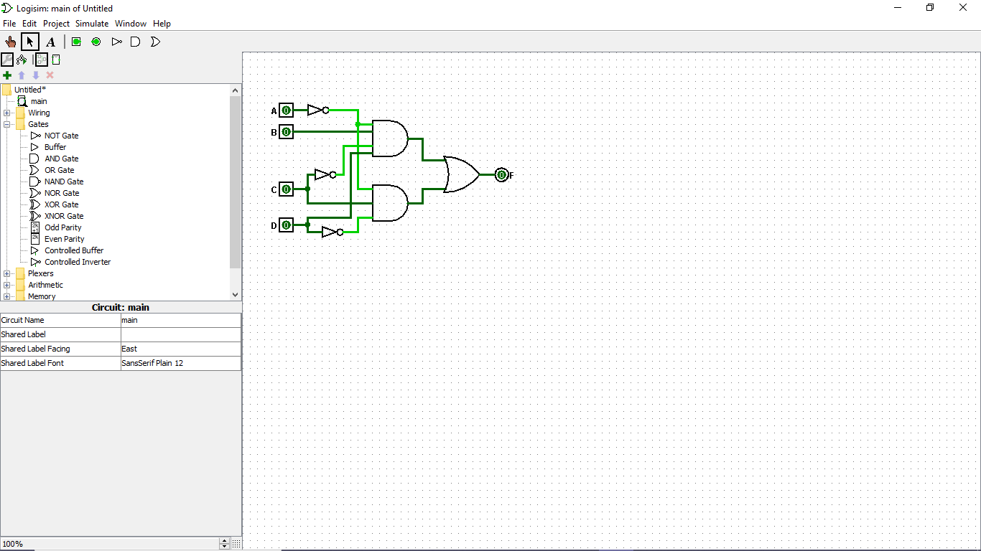

**Question 4: Given the function *f* (*a, b, c, d*) = *a’*(*b’* + *d*) + *acd’*, then:**

1. **Find the min-term expansion of the function f.**

f=a’b’+a’d+acd’  
 =a’b’(c+c’)(d+d’)+a’d(c+c’)(d+d’)+acd’(b+b’)  
 =a’b’c’d’+a’b’c’d+a’b’cd’+a’b’cd+a”bc”d+a’bcd+abcd’+ab’cd’  
 =∑m(0,1,2,3,5,7,10,14)

1. **Find the max-term expansion of the function f.**

f=(a’+cd’)(a+b’+d) **using Th. 13; (X+Y)(X’+Z)=XZ+X’Y**  
 =(a’+c)(a’+d’)(a+b’+d) **using Th. 8B; X+YZ=(X+Y)(X+Z)**  
 =(a’+bb’+c+dd’)(a’+bb’+cc’+d’)(a+b’+cc’+d)  
=(a’+b+c+d)(a’+b’c+d)(a’+b+c+d’)(a’+b’+c+d’)(a’+b+c’+d’)(a’+b’+c’+d’)(a+b’+c+d)(a+b’+c’+d)  
 =∏M(4,6,8,9,11,12,13,15)

**Question 5: Simplify the following expression to two terms using boolean algebra theorems**

***AB’* + *A’C’D’*+ *A’B’D* + *A’B’CD’***

*AB’* + *A’C’D’*+ *A’B’D* + *A’B’CD’*

*AB’* + *A’C’D’*+ *(A’+B’)D* + *(A’+B’)CD’* **using Th. 14; (XY)’=X’+Y’**

*AB’* + *A’C’D’*+ *(A’+B’)(D+CD’)* **using Th. 8A; X(Y+Z)=XY+XZ**

*AB’* + *A’C’D’*+ *(A’+B’)(D+C)* **using Th. 11B; X+(X’Y)=X+Y**

*AB’* + *A’C’D’*+ *(D+C)A’+(D+C)B’* **using Th. 8A; X(Y+Z)=XY+XZ**

*AB’* +*A’D+A’C+B’D+B’C +A’C’D’* **using Th. 8A; X(Y+Z)=XY+XZ**

*AB’* +*A’D+A’C+ B’C +A’C’D’* **using Th. 12B; XY+X’Z+YZ= XY+X’Z**

*AB’+B’C+A’(D+C+C’D’)* **using Th. 8A; X(Y+Z)=XY+XZ**

*AB’+B’C+A’(D+C+C’+D’)* **using Th. 14; (XY)’=X’+Y’**

*AB’+B’C+A’(D+D’+1)* **using Th. 5A; X+X’=1**

*AB’+B’C+A’* **using Th. 2A; X+1=1 and Th. 1B, X1=X**

*B’+B’C+A’* **using Th. 11B; X+(X’Y)=X+Y**

*B’+A’* **using Th. 10A; X+XY=X**

**Question 6: Simplify the following expression to a minimum number of terms, and at the same time, the simplified expression shall be expressed in POS format. Use boolean algebra theorems.**

***CD* + *AB’* + *AC* + *A’C’* + *A’B* + *C’D’***

**Complement:**

(C’+D’)(A’+B)(A’+C’)(A+C)(A+B’)(C+D)

(A’C’+A’D’+BC’+BD’)(AA’+A’C+CC’+AC’)(AC+AD+B’C+B’D) **using Th. 8A; X(Y+Z)=XY+XZ**

(A’C’+A’D’+BC’+BD’)(A’C+AC’)(AC+AD+B’C+B’D) **using Th. 5B; XX’=0 and Th. 1A, X+0=X**

(A’CA’C’+A’CA’D’+A’CBC’+A’CBD’+AC’A’C’+AC’A’D’+AC’BC’+AC’BD’)(AC+AD+B’C+B’D) **using Th. 8A; X(Y+Z)=XY+XZ**

(A’CA’D’+A’CBD’+AC’BC’+AC’BD’)(AC+AD+B’C+B’D) **using Th. 5B; XX’=0 and Th. 2B; X*0=0**

(A’CD’+A’CBD’+ABC’+AC’BD’)(AC+AD+B’C+B’D) **using Th. 3B; XX=X**

A’CD’AC+A’CBD’AC+ABC’AC+AC’BD’AC+A’CD’AD+A’CBD’AD+ABC’AD+AC’BD’AD+A’CD’B’C+A’CBD’B’C+ABC’B’C+AC’BD’B’C+A’CD’B’D+A’CBD’B’D+ABC’B’D+AC’BD’B’D **using Th. 8A; X(Y+Z)=XY+XZ**

ABC’AD+A’CD’B’C **using Th. 5B; XX’=0 and Th. 2B; X*0=0**

ABC’D+A’BCD’ **using Th. 3B; XX=X**

**Converting to POS Form:**

[ABC’D+A’BCD’]’

(A’+B’+C+D’)(A+B’+C’+D)

**Question 7: Simplify each of the following expressions to a minimum number of terms, and at the same time, each term shall consists of a minimum number of variables. Use boolean algebra theorems.**

***XY* + *X’Y Z’* + *Y Z***

*XY* + *X’Y Z’* + *Y Z*

*Y(X* + *X’ Z’)* + *Y Z* **using Th. 8A; X(Y+Z)=XY+XZ**

*Y(X* + *Z’)* + *Y Z* **using Th. 11B; X+(X’Y)=X+Y**

*YX* + *YZ’* + *Y Z* **using Th. 8A; X(Y+Z)=XY+XZ**

*YX* + *Y(Z’* + *Z)* **using Th. 8A; X(Y+Z)=XY+XZ**

*YX* + *Y* **using Th. 5A; X+X’=1 and Th. 1B, X1=X**

*Y* **using Th. 10A; X+XY=X**

***XY’*+ *Z* + (*X’* + *Y* )*Z’***

*XY’*+ *Z* + (*X’* + *Y* )*Z’  
XY’*+ *Z* + *Z’X’* +*Z’Y* **using Th. 8A; X(Y+Z)=XY+XZ** *XY’*+ *Z* + *Z’+X’* +*Z’Y* **using Th. 14; (XY)’=X’+Y’**

*XY’*+ *1+X’* +*Z’Y* **using Th. 5A; X+X’=1***1* **using Th. 2A; X+1=1**

**(*XY’* + *Z*)(*X* + *Y’*)*Z***

(*XY’* + *Z*)(*X* + *Y’*)*Z*

(*X* + *Y’*)*ZXY’+*(*X* + *Y’*)*ZZ* **using Th. 8A; X(Y+Z)=XY+XZ**

(*X* + *Y’*)*ZXY’+*(*X* + *Y’*)*Z* **using Th. 3B; XX=X**

(*X* + *Y’*)*Z* **using Th. 10A; X+XY=X**

*ZX* + *ZY’* **using Th. 8A; X(Y+Z)=XY+XZ**

**Question 8. Problem 2.2 (e) and 2.2 (f) Simplify to min. number of variables**

1. **(a + b + c’)(a’b’ + c)**

aa'b' + ac + ba'b' + bc + c'a'b' + c'c **using Th. 8A; X(Y+Z)=XY+XZ**

=ac + bc +a'b'c' **using Th. 5B; XX’=0**

1. **a’bc + abc’ + abc + a’bc’**

a'b(c + c') + ab(c + c') **using Th. 8A; X(Y+Z)=XY+XZ**

a'b + ab **using Th. 5A; X+X’=1 and Th. 1B, X1=X**

b(a' + a) **using Th. 8A; X(Y+Z)=XY+XZ**

=b **using Th. 5A; X+X’=1 and Th. 1B, X1=X**

**Question 9. Problem 2.8 Find the complement of F = wx + yz; then show that FF’ = 0 and F + F’ = 1**

F’= (wx + yz)’ = (wx)’(yz)’ = (w’ + x’)(y’ + z’) **using DeMorgan’s Laws**

FF’= wx(w’ + x’)(y’ + z’) + yz(w’ + x’)(y’ + z’)= wx(wx)’(yz)’ + yz(wx)’(yz)’= 0 **using Complement, Annulment, and Identity Laws**

F + F’= (wx + yz) + (wx + yz)’ = X + X’= 1 **using Complement Laws**

**Question 10. Problem 2.9 (c) Find the complement**

**c. z + z’(v’w + xy)**

[z + z’(v’w + xy)]’

z’[z’v’w + z’xy]’

z’[(z + v + w’) +( z + x’ + y’)]

z’z + z’v + z’w’ + z’z + z’x’ + z’y’

z’v + z’w’ + z’x’ + z’y’

z’(v + w’ + x’ + y’) **using DeMorgan’s, Distributive, and Identity Laws**

**Question 11. Problem 2.13 (c) using NOR only and 2.13 (e) using only NAND**

**c. y = (u’ + x’) (y + z’)**

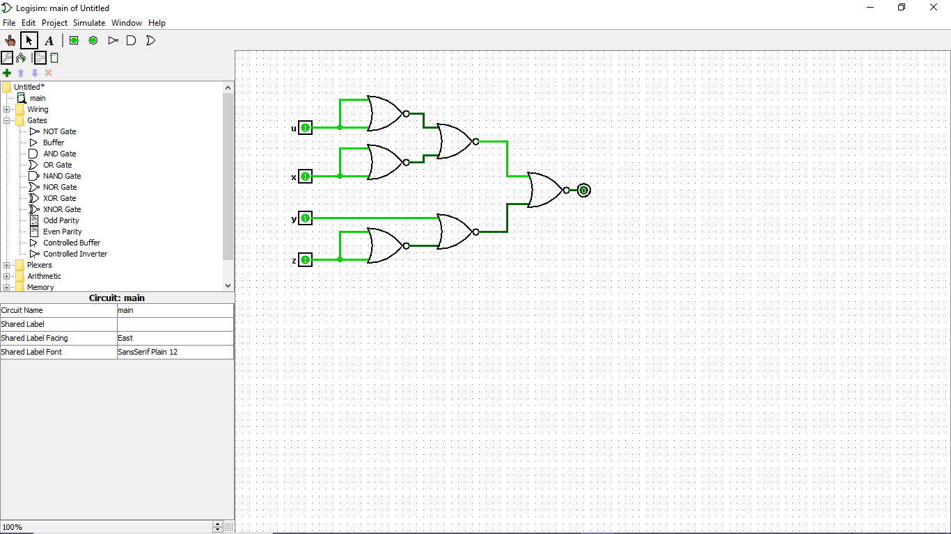

**e. y = u + yz + uxy**

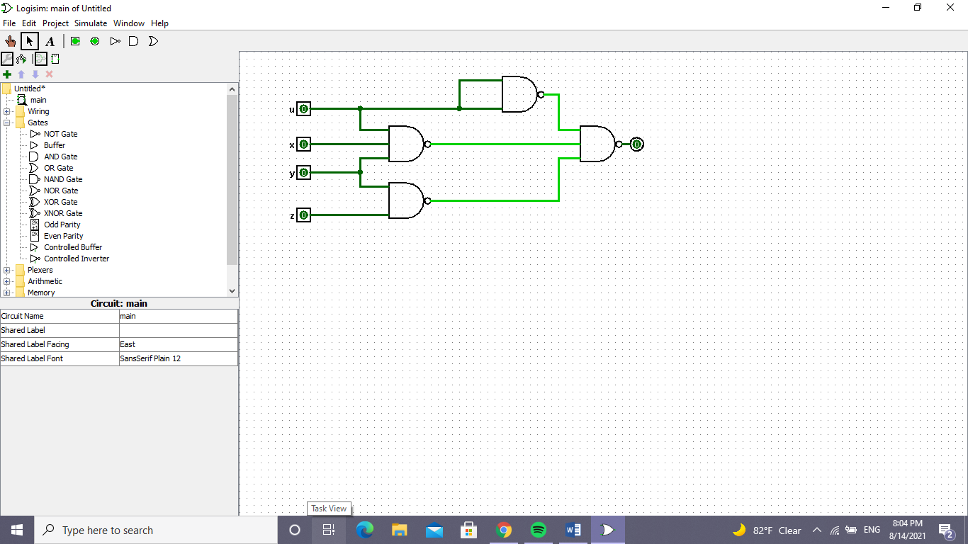

**Question 12. Problem 2.17 (d)**

**d. bd’ + acd’ + ab’c + a’c’**

**Truth Table:**

|  |  |  |  |  |
| --- | --- | --- | --- | --- |
| A | B | C | D | F |
| 0 | 0 | 0 | 0 | 1 |
| 0 | 0 | 0 | 1 | 1 |
| 0 | 0 | 1 | 0 | 0 |
| 0 | 0 | 1 | 1 | 0 |
| 0 | 1 | 0 | 0 | 1 |
| 0 | 1 | 0 | 1 | 1 |
| 0 | 1 | 1 | 0 | 1 |
| 0 | 1 | 1 | 1 | 0 |
| 1 | 0 | 0 | 0 | 0 |
| 1 | 0 | 0 | 1 | 0 |
| 1 | 0 | 1 | 0 | 1 |
| 1 | 0 | 1 | 1 | 1 |
| 1 | 1 | 0 | 0 | 1 |
| 1 | 1 | 0 | 1 | 0 |
| 1 | 1 | 1 | 0 | 1 |
| 1 | 1 | 1 | 1 | 0 |

**Function in sum-of-minterms form:**

F=∑m(0, 1, 4, 5, 6, 10, 11, 12, 14)

**Function in product-of-maxterms form:**

F=∏M (2, 3, 7, 8, 9, 13, 15)